**Introduction to Open-Source Software**

B. Tech Integrated /Computer / Sem IV

**PART A**

(PART A: TO BE REFFERED BY STUDENTS)

**Experiment No.10**

**A.1—Aim:**

To Create and use a repository using on GitHub.

**A.2--- Prerequisite:**

Account on GitHub

**A.3---- Theory:**

GitHub is a code hosting platform for version control and collaboration. It lets you and others work together on projects from anywhere. We can:

* Create and use a repository
* Start and manage a new branch
* Make changes to a file and push them to GitHub as commits
* Open and merge a pull request

## **Creating a repository**

A repository is usually used to organize a single project. Repositories can contain folders and files, images, videos, spreadsheets, and data sets -- anything your project needs. Often, repositories include a README file, a file with information about your project. README files are written in the plain text Markdown language. You can use this [cheat sheet](https://www.markdownguide.org/cheat-sheet/) to get started with Markdown syntax. GitHub lets you add a README file at the same time you create your new repository. GitHub also offers other common options such as a license file, but you do not have to select any of them now.

Your hello-world repository can be a place where you store ideas, resources, or even share and discuss things with others.

1. In the upper-right corner of any page, use the  drop-down menu, and select **New**

**repository**.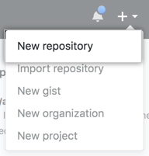

1. In the **Repository name** box, enter hello-world.
2. In the **Description** box, write a short description.
3. Select **Add a README file**.
4. Select whether your repository will be **Public** or **Private**.
5. Click **Create repository**.

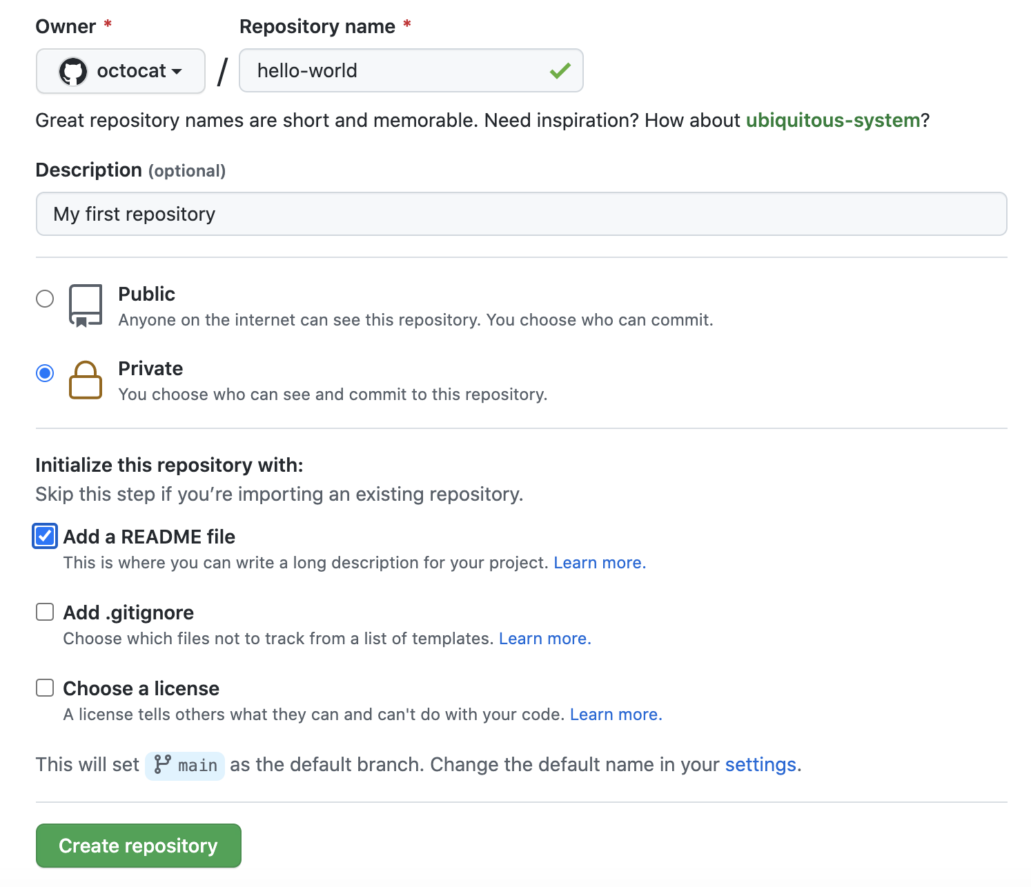

**A.3--- Tasks:**

1. Create an account on GitHub
2. Deploy experiment no. 8 and 9 on GitHub. The files should include:

The main **Project file (Which will include Part B of experiment), Instruction file (Set of instructions related to project, Requirement file(Any software which required to be installed and any data folders needs to be uploaded along with the main project)**

Take screen shots of repository and add to the file and name it as **EXP10_ your Roll no.**

**Also add your account ID in the file.**

**(PART - B)**

(TO BE COMPLETED BY STUDENTS)

(Students must submit the soft copy as per following segments within two hours of the practical.

The soft copy must be uploaded on the Blackboard or emailed to the concerned lab in charge faculties at the end of the practical in case there is no Black board access available)

|  |  |
| --- | --- |
| Roll.No. : | Name: |
| Sem/Year : | Batch: |
| Date of Experiment : | Date of Submission: |
| Grade -- |  |

# B.1: Procedure of performed experiment

(students are expected to write the reason of the choice of topology and device)

# B.2: Observations and Learning’s:

(Students are expected to comment on the output obtained with clear observations and learning for each task/ sub part assigned)

# B.3: Conclusion:

(Students must write the conclusion as per the attainment of individual outcome listed above and learning/observation noted in section B.2)